Vishal Maru

Dr. Bukralia

IT 340

Assignment #3

April 8, 2018

#1

SELECT ProductID, AVG(OrderQty) AS [AverageQuantity],

Total = SUM(LineTotal)

FROM Sales.SalesOrderDetail

GROUP BY ProductID

HAVING AVG(OrderQty) < 3

AND SUM(LineTotal) > 1000000;

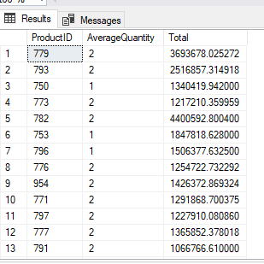

#2

SELECT ProductID, SUM(LineTotal) AS Total

FROM Sales.SalesOrderDetail

GROUP BY ProductID

HAVING SUM(LineTotal) > 2000000;

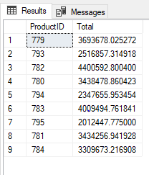

#3

SELECT ProductID, SUM(LineTotal) AS Total

FROM Sales.SalesOrderDetail

GROUP BY ProductID

HAVING COUNT(ProductID) > 1500;

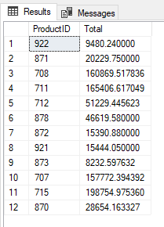

#4

SELECT PhoneNumber

FROM Person.PersonPhone

WHERE PhoneNumber LIKE '415%';

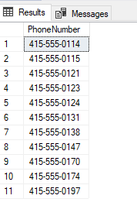

#5

SELECT PhoneNumber

FROM Person.PersonPhone

WHERE PhoneNumber NOT LIKE '415%';

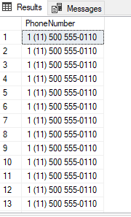

#6

SELECT ProductID, Name

FROM Production.Product

WHERE ListPrice > 14

AND ListPrice < 26;

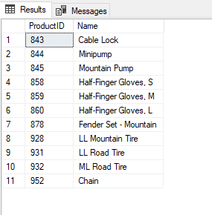

#7

SELECT BusinessEntityID, Name

FROM Sales.Store

WHERE BusinessEntityID LIKE '1%'

AND Name LIKE 'Bicycle%';

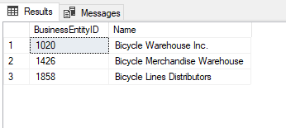

#8

SELECT ProductID

FROM Sales.SalesOrderDetail

GROUP BY ProductID

HAVING AVG(OrderQty) > 5;

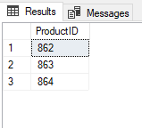

#9

SELECT e.BusinessEntityID

FROM Sales.SalesPerson AS sp

INNER JOIN HumanResources.Employee AS e

ON e.BusinessEntityID = sp.BusinessEntityID;

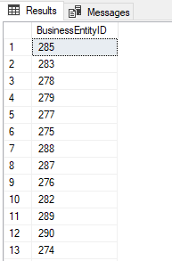

#10

SELECT E.JobTitle, E.Gender, E.VacationHours

FROM HumanResources.Employee AS E

LEFT OUTER JOIN Person.Person AS P

ON E.BusinessEntityID = P.BusinessEntityID

WHERE P.LastName LIKE 'A%';

